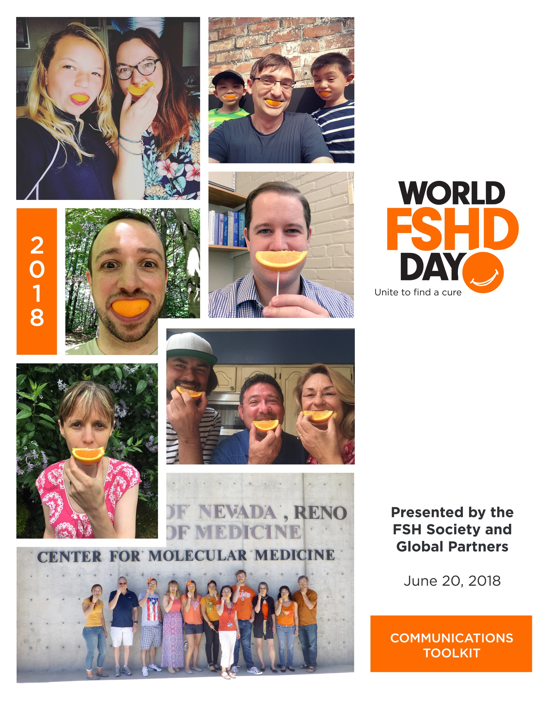
World FSHD Day Communications Toolkit

FSHD FAQ……………………………………………………………………………………………………………………………………. 2
What is FSHD?.......................................................................................................................... 2
How did FSHD get its name?.................................................................................................... 2
Can FSHD be cured?................................................................................................................. 2
What are the symptoms of FSHD?........................................................................................ 2-3
How is FSHD diagnosed?.......................................................................................................... 3
When are most people diagnosed with FSHD?..................................................................... 3-4
How common is FSHD?............................................................................................................. 4
How does FSHD progress?........................................................................................................ 4
Are there different forms of FSHD?.......................................................................................... 4
Are the symptoms the same for both FSHD Type 1 and Type 2?............................................. 4

What is World FSHD Day?.............................................................................................................. 5
What is the history around World FSHD Day?......................................................................... 5
Who is recognizing World FSHD Day?...................................................................................... 5
How are we recognizing World FSHD Day in 2018?................................................................. 5
How can I get involved?........................................................................................................... 6

Appendix 1: Campaign: Orange Slice Selfies………………………………………………………………………………… 7
What is an Orange Slice Selfie and how do I do it?.................................................................. 7
How do I share my Orange Slice Selfie on social media?......................................................... 7

Appendix 2: Campaign: Host A Local Event……………………………….…………………………………………………. 8
What are some event ideas I can do in my community?......................................................... 8
How do I publicize my event to my community?.................................................................. 8-9
How do I encourage people to spread the word about my event?.......................................... 9

Appendix 3: Campaign: Light the Night Orange…………………………………………………………………………… 10
What is Light the Night Orange?............................................................................................. 10
How do I write a letter to my local Department of Public Works?......................................... 10
If a building will be lit orange, how do I share the news?....................................................... 11
How do I share Light the Night Orange on social media?....................................................... 11

Appendix 4: Write a Proclamation to have World FSHD Day observed in your community…………. 12
What will writing a proclamation to my local government do?............................................. 12
How do I write a proclamation letter to my local government?............................................ 12
If World FSHD Day is declared and observed in my community, how do I share this news?.13

Appendix 5: Donate to the FSH Society on World FSHD Day & Share Official Logos…………………... 14
How do I make a donation to the FSH Society on World FSHD Day?.................................... 14
Where can I find the official logo for World FSHD Day?....................................................... 14

FSHD FAQ

What is FSHD?
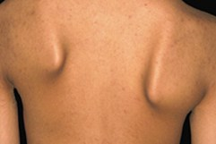
Facioscapulohumeral muscular dystrophy (FSHD) is broadly characterized as a neuromuscular disease (NMD), as are all types of muscular dystrophy. Muscular dystrophies are marked by progressive skeletal muscle weakness, defects in the biochemical, physical, and structural components of muscle, and the death of muscle cells and tissue. FSHD gets its name because the progressive loss of skeletal muscle is usually noticeable across facial (facio), back (scapula), and upper arm (humeral) muscles. The core, hip girdle, and legs can also be affected in many patients. Muscle weakness often sets in asymmetrically, affecting only one arm or one leg, for example, and as a result may be mistakenly attributed to a muscle strain or a sports injury. For even more information on FSHD, download this brochure and share it with others.
A common first sign of FSHD, asymptomatic scapular winging and difficulty reaching above the shoulder level

How did FSHD get its name?
FSHD gets its name because of the type of progressive loss of all skeletal muscle, where weakness is usually noticeable across facial (facio), back (scapula), and upper arm (humeral) muscles. Though it can seem like a daunting and long name to pronounce, we’ve broken it down for you to easily share the full name with others! Facio-scapulo-humeral (fā-sh(ē-)ō-ˌskap-yə-lō-ˈhyüm-(ə-)rəl), muscular dystrophy.

Can FSHD be cured?
Currently, there is no cure for FSHD, making the research we do and the awareness we raise all the more important in pinpointing a cure. Though there is no cure, physical therapy has shown to assist patients with FSHD maintain the muscle strength they do have and improve everyday life. For FSHD patients, individual physical therapy plans are emphasized as patients can present with a specific combination of muscle involvement and progress at a rate that is unique to them. For more information on physical therapy for those with FSHD, download our Physical Therapy and FSHD brochure.

What are the symptoms of FSHD?
Symptoms may manifest early, sometimes years before a formal diagnosis. These can (but don’t always) include:

- Inability to smile;
- Inability to whistle;
- Inability to sip through a straw;
- Eyes that don’t close fully during sleep;
- Difficulty with such exercises as sit-ups and pull-ups;
- Shoulder blades that “wing” out;
- Difficulty raising arm above shoulder height;
- Foot drop (foot dorsiflexion weakness);
- Weak lower abdominal muscles, protuberant abdomen;
- Loss of pectoral (chest) muscles;
- Curved spine (lordosis).

Patients can also experience:
- Episodes of “malaise” or “burning pain” in muscles;
- Severe pain from changes in posture and strain on remaining muscles;
- Chronic fatigue;
- Respiratory insufficiency;
- Hearing loss;
- Coats’ disease (retinal telangiectasis).

How is FSHD diagnosed?
The first step in diagnosing FSHD is a visit with a doctor for a physical exam. An initial diagnosis is based on the pattern of muscles affected. The doctor will also ask a series of questions about the patient’s family history and medical history. The following tests may be ordered to determine whether the problems are a result of FSHD:

- Blood tests to measure levels of serum creatine kinase (CK), an enzyme that is released into the bloodstream when muscle fibers are deteriorating, and serum aldolase, an enzyme that helps break down sugars into energy. Elevated levels of either of these enzymes can indicate a problem with muscles and a need for additional testing. However, a normal CK level does not rule out FSHD.
- Neurological tests to rule out other nervous system disorders, identify patterns of muscle weakness and wasting, test reflexes and coordination, and detect muscle contractures.
- Muscle biopsies, which involve the removal of muscle tissue using a biopsy needle or during a simple surgical procedure. The tissue is then examined under a microscope. In FSHD, a muscle biopsy might reveal several abnormalities, but none are uniquely characteristic for the disease, or the muscle might even appear normal. To confirm a diagnosis of FSHD with certainty, a genetic test is needed.
- Genetic testing to confirm FSHD Type 1 or Type 2.

Though there are many forms of diagnosing FSHD, a full breakdown can be found on the diagnosis page via the FSH Society website.
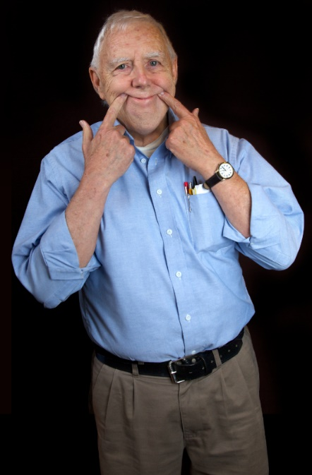
When are most people diagnosed with FSHD?
The age of onset can range from infancy to adulthood. The eventual extent and degree of muscle loss is also highly variable. The prognosis for FSHD includes a loss of muscular strength that limits both personal and occupational activities, and approximately one-quarter of patients over 50 years of age require the use of a wheelchair.

Thirty percent of new FSHD patients have no prior family history of the disease and are a result of congenital spontaneous genetic mutation. Once present, however, FSHD is genetically transmissible in an autosomal dominant fashion. This means that an affected parent has a 50 percent chance of passing the genetic defect on to each child.

How common is FSHD?
FSHD is the most prevalent of the nine primary types of muscular dystrophy affecting adults and children. It is a genetic disorder. Previously, studies estimated the prevalence at around 1 in 20,000 people, but a 2014 Dutch study reported a much higher prevalence of 1 in 8,333. Estimated to affect about 870,000 individuals worldwide, the actual number of individuals with FSHD could be significantly higher due to undiagnosed cases.

FSHD is worldwide in distribution, affects both sexes equally, and has no particular racial, geographic, or ethnic distribution.

How does FSHD progress?
Although the progression of FSHD is quite variable, it is usually relatively slow, with most patients developing noticeable muscle weakness by the age of 20 in males and by the age of 30 in females.

Are there different forms of FSHD?
Yes, there are two forms known as Type 1 and Type 2. Approximately 95 percent of FSHD cases are known as Type 1 (chromosome 4-linked FSHD; also called FSHD1 or Type 1A). FSHD1 is linked to deletions of D4Z4 units on chromosome 4.

The remaining 5 percent of FSHD cases have normal-length D4Z4 regions on chromosome 4 and are called Type 2 (FSHD2, also called Type 1B). A majority of FSHD2 has now been linked to mutations on a gene called SMCHD1, on chromosome 18. There are still ~1 percent of FSHD cases of unknown genetic cause.

Are the symptoms the same for both FSHD Type 1 and Type 2?
Yes, both FSHD1 and FSHD2 have similar symptoms. Even though the genetic causes are distinct, both types appear to have the same end result at the molecular level: they cause the D4Z4 region to have less-than-normal levels of methylation, which allows the DUX4 gene to get expressed. So, in spite of different genetics, FSHD1 and FSHD2 appear to be the same disease.

What is World FSHD Day?

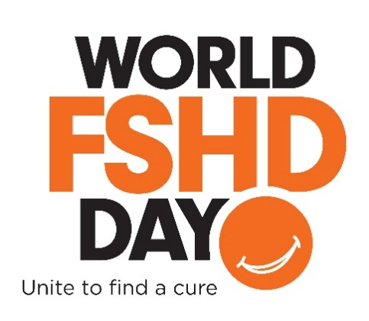
Every June 20th, we gather to raise awareness for Facioscapulohumeral muscular dystrophy (FSHD) through World FSHD Day. Participants from across the globe, advocacy organizations, individuals with FSHD as well as their families and supporters, come together in various ways to raise awareness for FSHD, one of the most prevalent forms of muscular dystrophy.

The FSH Society and fellow members of FSHD Champions, the international alliance of FSHD advocacy organizations, look to recognize individuals with FSHD, their families, physicians, researchers and supporters by participating in our Orange Slice Selfie campaign and taking part in various local activities.

What is the history around World FSHD Day?
In 2016, we celebrated our inaugural World FSHD Day. In addition to the FSH Society and other advocacy groups in the U.S., other countries took part in World FSHD Day, including Italy, France, the Netherlands, Germany, Austria, the United Kingdom, Canada, Australia, Japan and China.
In 2017, the FSH Society embarked on our first social media campaign to recognize World FSHD Day with the Orange Slice Selfies campaign. The campaign asked supporters to post a photo of themselves to social media using an orange slice in place of their smile with the official hashtag #WorldFSHDDay. The campaign is designed to stand out on social media by combining the event’s official color, bright orange, with an eye-catching image representing a symptom experienced by many patients: the loss of the ability to smile. With your support, we were able to reach over 12 million unique accounts on Twitter! This could not have been possible with out your dedication, creativity and willingness to raise awareness to FSHD on June 20th.

Who is recognizing World FSHD Day?
We encourage everyone to take part in our different awareness campaigns! Though individuals with FSHD, their families and their supporters will be recognizing the day, we invite others all around the world to stand with them in solidarity.

How are we recognizing World FSHD Day in 2018?
For our 2018 celebrations, we hope to replicate the same success we had in 2017 and make the day even bigger. But we can’t do this without your support. This year, we will be continuing to build on our Orange Slice Selfie campaign in the hopes of reaching an even larger audience on social media, while directing supporters to our donations page. Our goal is to achieve $10,000 in donations on June 20th.

How can I get involved?
There are many ways you can support us in our quest to make this World FSHD Day even better! Whether you’d like to support us online or get in touch with your local community, there is an action for you to take.
- Participate in our Orange Slice Selfies Campaign: Looking for an easy, simple way to show your support? Join us in our Orange Slice Selfie campaign! Like any other selfie, capture yourself or your friends somewhere you love, but replace your smile with an orange slice. Be sure to use the official hashtag, #WorldFSHDDay in your post!
- Host a local event in your area to celebrate the day: Want to take on a larger commitment and unify your community during World FSHD Day? We welcome all supporters to host their own small event to gather people together to show their support and raise awareness.
- Work with your local Department of Public Works to Light the Night Orange: Beyond orange slices and events, we appreciate all supporters in helping to light local landmarks orange! In Boston, MA, the famed Zakim Bridge has lit orange in support of World FSHD Day. Join us in our quest to light the country orange from coast to coast!
- Write a proclamation to have World FSHD Day observed in your community: Though our community recognizes World FSHD Day across the globe, we encourage supporters to write to their local state governments to proclaim June 20th as World FSHD Day to be observed by all.
- Make a donation: Looking to support the FSH Society and World FSHD Day but unable to donate time or additional resources to our campaigns? We welcome any and all donations on World FSHD Day to help us reach our goal of raising $10,000 on June 20th!

Whichever way you wish to support us in our efforts to spread awareness to FSHD on World FSHD Day, please continue reading through this toolkit for more information on how to make your voice heard.

Appendix 1: Campaign: Orange Slice Selfies

What is an Orange Slice Selfie and how do I do it?

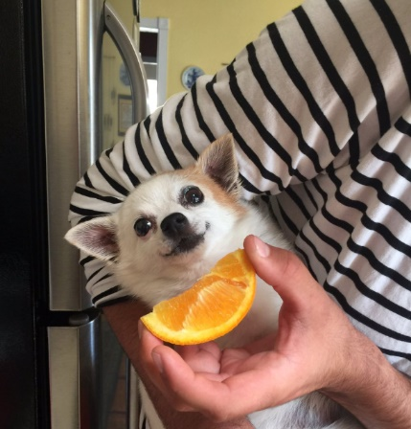
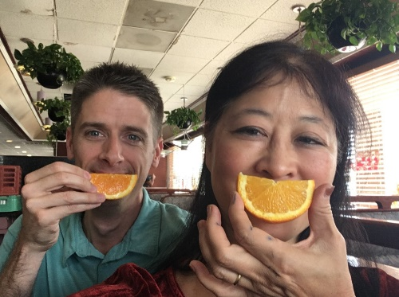
Slice, smile and snap! Taking part in our Orange Slice Selfie campaign is just that simple. Though each selfie includes the classic orange slice in place of a smile, what makes each one special is what you add to it. Grab your friends, family or pets and help us to bring awareness to FSHD and the FSH Society. Don’t forget to include #WorldFSHDDay in your post!

How do I share my Orange Slice Selfie on social media?

Now that you’ve got your Orange Slice Selfie photo ready, what is the best way to share your photo? We’ve included sample posts below to help you get the right words down. Don’t forget to tag your friends, the FSH Society (@FSHSociety on Twitter) and include our official hashtag, #WorldFSHDDay!

Facebook Suggestions
- Mark your calendars, June 20, 2018, is World FSHD Day! The day serves to gather individuals with FSHD, their families and supporters to raise awareness to the disease. To learn more, check out https://www.fshsociety.org/
- On June 20, I’m raising awareness for World FSHD Day by sharing an Orange Slice Selfie! Share a photo of your Orange Slice Selfie to show your support to #WorldFSHDDay & the @FSHSociety
- Today is #WorldFSHDDay! To unite our community & raise awareness to the disease, I’m sharing my Orange Slice Selfie. Join me by sharing yours or by making a donation to the @FSHSociety

Twitter Suggestions
- Mark your calendars, 6/20 is #WorldFSHDDay! Help us raise awareness to #FSHD & the @FSHSociety across the globe
- I’m wearing my Orange Slice Selfie this #WorldFSHDDay to raise awareness to #FSHD on 6/20. Share your smile w/ the @FSHSociety & make a donation today!
- Did you know #FSHD impacts 870K people worldwide? I’m sharing my Orange Slice Selfie on 6/20 to raise awareness for #WorldFSHDDay & ask you to do the same!
- Today is #WorldFSHDDay, put on your Orange Slice Selfie on & support the @FSHSociety!
- It’s #WorldFSHD Day! I’m sharing my Orange Slice Selfie to raise awareness & ask that you join me. To learn more & donate, check out https://bit.ly/2GHOx1s

Appendix 2: Campaign: Host A Local Event

What are some event ideas I can do in my community?

Local events within the community are a great way to bring supporters closer together to raise awareness. Each event does not need to be extravagant. The important part is that supporters are coming together to share the day and make others aware of FSHD in the hopes of one day finding a cure. Some ideas for local events include:
- A walk & roll from one landmark to another in your community
- A meetup at a local park giving away orange slices for others to take their Orange Slice Selfie
- An education day at a local university, high school, town hall or other event to spread awareness

How do I publicize my event to my community?

The best way to spread awareness towards your event is to share it with your local newspapers and TV stations. Below is a template of a media alert that can be used to organize the details of your event into one easy document for sharing with your local media. We encourage you to customize this media alert with the details for your own event.

MEDIA ALERT: [GROUP] to Host [EVENT] Celebrating Third Annual World FSHD Day

WHAT: On DATE, join ORGANIZATION at the EVENT NAME at LOCATION to recognize the third annual World FSHD Day! This event will help to raise awareness to Facioscapulohumeral Muscular Dystrophy (FSHD) on June 20th (World FSHD Day) in the hopes of one day finding a cure.
Families, friends and supporters are welcome, and all net proceeds benefit the FSH Society, an award-winning non-profit and global leader in the quest to treat and cure FSHD. To donate online to the FSH Society in support of World FSHD Day, please visit www.fshsociety.org.

WHEN: MONTH DAY, 2018 from TIME to TIME am/pm.

WHERE: NAME OF LOCATION
ADDRESS OF LOCATION

WHY: Facioscapulohumeral muscular dystrophy, FSHD, is a genetic disorder for which there is no cure. Typically beginning in the teenage years, the disease leads to a gradual weakening of skeletal muscles in the face (facio), shoulders (scapula), upper arms (humerus), legs or core. Through this event, we hope to bring awareness to the disease on World FSHD Day to further advance research for a cure.

CONTACT: LOCAL ORGANIZER ONSITE CONTACT INFORMATION
FIRST NAME, LAST NAME
EMAIL
PHONE

About the FSH Society: The FSH Society is the world’s largest research-focused patient organization for facioscapulohumeral muscular dystrophy (FSHD), one of the most prevalent forms of muscular dystrophy. We have catalyzed major advancements and are accelerating the development of treatments and a cure to end the pain, disability, and suffering endured by one million people worldwide who live with FSHD. The FSH Society has transformed the landscape for FSHD research, and is committed to making sure that no one faces this disease alone. The Society offers a community of support, news, and information through its website at https://www.fshsociety.org.

How do I encourage people to spread the word about my event?

In addition to sharing your event with your local media outlets, we encourage using social media platforms such as Facebook and Twitter to spread the word about your event. Facebook events are a great way to share the important details about your event and encourage others to connect online and build a friendship.

Working with other local community groups to promote your event via social media will also draw attention to your event. We recommend connecting with other organizations via social media, or contacting them via their website, if applicable.

Appendix 3: Campaign: Light the Night Orange

What is Light the Night Orange?

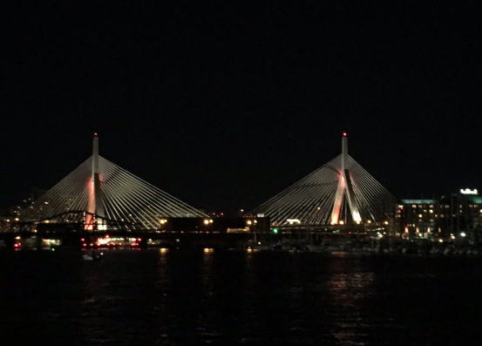
Light the Night Orange is a chance for us to light notable landmarks orange from coast to coast in on World FSHD Day. Lighting landmarks such as Boston’s Zakim Bridge orange not only increases attention to FSHD but serves as a chance for our community to educate others that may not be familiar with the disease.

How do I write a letter to my local Department of Public Works?

Getting the right words together can be challenging. Thankfully, we’ve included a template letter below for sending to your local Department of Public Works official. We encourage you to customize this letter as you see fit.

DATE
ADDRESS OF LOCAL PUBLIC WORKS OFFICE

Dear NAME,

My name is NAME and I serve as TITLE/MEMBER NAME of the FSH Society. I am writing to ask for a very special favor—to light up BUILDING orange this June 20th in honor of patients and families around the world who suffer from Facioscapulohumeral muscular dystrophy (FSHD).

This year, we will be celebrating the third annual World FSHD Day through awareness campaigns with patients, researchers and organizations worldwide to educate the public and advocate for research for a cure. We would greatly appreciate for World FSHD Day 2018 to serve as an opportunity to spread awareness of FSHD, especially in CITY. To that end, we would like to ask that you to kindly arrange for BUILDING to be lit orange on the night of June 20th, the official color for World FSHD Day.

If you can accommodate our request, we will promote it through a worldwide social media campaign, sharing images of BUILDING in the World FSHD Day colors over Facebook and Twitter. This would be an incredibly powerful way to rally our community, with BUILDING giving visibility to FSHD on a scale that we have never had before.

The FSH Society is the world’s leading nonprofit organization advocating for treatments for facioscapulohumeral muscular dystrophy. FSHD is the most common form of muscular dystrophy, causing progressive skeletal muscle loss. It affects almost a million people worldwide and there is no cure. But thanks to recent advances in research, we hope treatments will be developed soon.

For more information on the FSH Society, please visit https://www.fshsociety.org/. We hope that you will consider standing with FSHD patients, especially right here in CITY, by lighting BUILDING orange in their honor this June 20th.

Sincerely,
NAME

If a building will be lit orange, how do I share the news?

Congratulations! We’re thrilled to add another city landmark to our list of locations being lit orange for World FSHD Day. Now, it’s time to spread the news to your local TV stations to encourage them to share live shots of the landmark lit orange for the night. Below is a template email note for sharing with the news desks or night time reporters at your local news stations. Please feel free to customize this email as you see fit with specific details that pertain to your area.

Email Subject: BUILDING lights up orange for World FSHD Day, 6/20
Hi NAME,

On June 20, BUILDING will light up orange to recognize World FSHD Day and honor patients and families in CITY and around the world who suffer from FSH muscular dystrophy (FSHD).

June 20, 2018, marks the third annual World FSHD Day. The day serves as a chance to raise awareness towards this particular form of muscular dystrophy and advocate for research to find a cure. With orange as the official color of World FSHD Day, please consider a shot of BUILDING being lit orange within your broadcast on June 20th.

FSHD is a genetic disorder for which there is no cure. Typically beginning in the teenage years, the disease leads to a gradual weakening of skeletal muscles in the face (facio), shoulders (scapula), upper arms (humerus), legs or core. It is the most prevalent form of muscular dystrophy, affecting more than 870,000 worldwide. To learn more, visit the nonprofit FSH Society at www.fshsociety.org.

Thank you for your support,
NAME

How do I share Light the Night Orange on social media?

In addition to spreading the word to your local news stations, we encourage you to take a photo of your landmark being lit orange and share it on social media using the hashtag, #WorldFSHDDay. Below are suggested posts for your use on Facebook and Twitter.

Facebook Suggestions
- On June 20, CITY is raising awareness for World FSHD Day by lighting BUILDING orange! Stop by at TIME to share a photo
- Today is #WorldFSHDDay! To unite our community & raise awareness, BUILDING is lighting orange for those with FSHD. Be sure to stop by to share a photo for #WorldFSHDDay!

Twitter Suggestions
- BUILDING will be lighting up orange to recognize #WorldFSHDDay on 6/20! Stop by & share a photo to show support
- DYK: #FSHD affects 870K people worldwide? BUILDING will be lighting the night orange on 6/20 to raise awareness for #WorldFSHDDay!
- Today is #WorldFSHDDay! BUILDING is lighting the night orange in celebration, be sure to share a photo!

Appendix 4: Write a Proclamation to have World FSHD Day observed in your community

What will writing a proclamation to my local government do?

Though World FSHD Day is celebrated by individuals around the globe, we ask that you assist us in continuing to show your support by writing a letter to your local state government proclaiming June 20th as World FSHD Day in your area and to be observed as such.

By writing a proclamation letter to the officials in your area, you can further help to recommend that the day be observed in an appropriate manner by the people.

How do I write a proclamation letter to my local government?

Getting the right words together can be challenging, so we’ve included a template letter below for sending to your local state government asking for their proclamation of June 20th as World FSHD Day. We encourage you to customize this letter as you see fit.

DATE
HONORIFIC TITLE OF PUBLIC OFFICIAL
ADDRESS

Dear TITLE AND NAME,

On behalf of the FSH Society and our patients and families, I am writing to enlist your support in raising the visibility of Facioscapulohumeral muscular dystrophy (FSHD) by issuing a public proclamation this June 20th, which is World FSHD Day.

On this day, advocacy groups around the world will hold events and share messages on social media to bring awareness to this debilitating muscle disease. We ask STATE/CITY to join these voices by issuing a proclamation and recommending that the day be observed in an appropriate manner by the people. Your support will bring hope to our patients and families.

OPTIONAL: ADD PERSONAL NOTE, YOUR POSITION IN THE COMMUNITY OR AS A CONSTITUENT, YOUR CONNECTION TO FSHD.

FSHD affects nearly one million individuals worldwide and results in the progressive loss of all skeletal muscle. Scientific progress on this disease could not only lead to treatments for a cure but will also benefit a wide range of areas of medicine, from cancer and diabetes to muscle regeneration and repair.

ADD DESCRIPTION OF LOCAL/REGIONAL CONNECTIONS TO FSHD CLINICAL CARE AND RESEARCH; E.G. HOSPITALS THAT HAVE MUSCULAR DYSTROPHY CLINICS, RESEARCH LABS, BIOTECHS, AS WELL AS LOCAL FUNDRAISING EVENTS.

I look forward to working with you and your team to further these important efforts.

Sincerely,
NAME

If World FSHD Day is declared and observed in my community, how do I share this news?

Congratulations! We’re thrilled to add another city to our list of locations proclaiming June 20th as World FSHD Day and to be recognized as such. Now, it’s time to spread the news to your local newspapers and TV stations to encourage them to spread the word. Below is a template email note for sharing with local newspaper and TV reporters in your area. Please feel free to customize this email as you see fit with specific details that pertain to your area.

Subject: LOCAL STATE GOVERNMENT OFFICIAL Proclaims June 20th as World FSHD Day
Hi NAME,

LOCAL STATE GOVERNMENT OFFICIAL has signed a proclamation declaring June 20th World FSHD Day in honor of patients and families in CITY and around the world who suffer from FSH muscular dystrophy (FSHD).

June 20, 2018 marks the third annual World FSHD Day. The day serves as a chance to raise awareness towards this particular form of muscular dystrophy and advocate for research to find a cure.

FSHD is a genetic disorder for which there is no cure. Typically beginning in the teenage years, the disease leads to a gradual weakening of skeletal muscles in the face (facio), shoulders (scapula), upper arms (humerus), legs or core. It is the most prevalent form of muscular dystrophy, affecting more than 870,000 worldwide. To learn more, visit the nonprofit FSH Society at www.fshsociety.org.

Please consider sharing this news within your coverage of local happenings in the area.

Thanks,
NAME

Appendix 5: Donate to the FSH Society on World FSHD Day & Share Official Logos

How do I make a donation to the FSH Society on World FSHD Day?

Looking to support the FSH Society in our efforts to celebrate World FSHD Day, but prefer to do so without directly participating in our other campaigns? We appreciate your support via donation as well. With your help, we look forward to reaching our goal of $10,000 raised on June 20th! To make a donation, please visit the donations page on the FSH Society website.

Where can I find the official logo for World FSHD Day?

In addition to the various ways to bring attention to World FSHD Day, we also encourage the use of our official logo in your efforts! The below logos can be used to assist in promoting local events and reaching out to the local media. We also encourage supporters to use the images on social media, even changing their profile pictures to the official World FSHD Day logo leading up to June 20th.

Please note that the JPEG version of this logo is best used for sharing the image via email or print, while the PNG version of this logo can be used in social media posts.

JPEG:
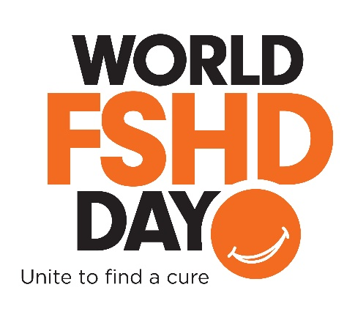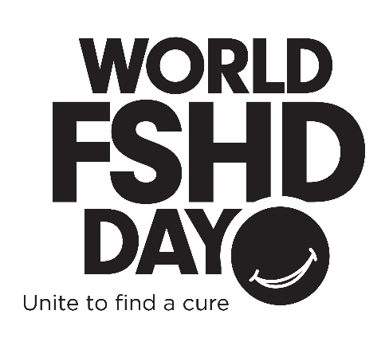

PNG:
