

FSH Society, Inc.
Fundraising Guide

AUCTIONS

Table of contents

Introduction 3
Auction Timetable 4
Putting together an auction committee 6
Procuring items for your auction 7
Setting up for the auction 8
Collecting money 9
Post-Auction follow up 10
Appendix A — Letter from the Director 11
Appendix B — Sample Procurement Letter 12
Appendix B — Sample Procurement Letter (2) 13
Appendix C — Sample Donation Form 14
Appendix D — Sample Auction Tracking Sheet 15
Appendix E — Sample Display Sheet 16
Appendix F — Sample Certificate 17
Appendix G — Sample Bidding Sheet 18
Appendix H — Sample Auction Program 19
Appendix I — Thank You Letter to Donor 20
Appendix J — Thank you Letter to Bidder 21

Introduction

Congratulations on your decision to hold an FSH Society fundraising auction! Putting on a successful auction takes some effort, but the rewards can be great.

Hopefully this guide will assist others who are interested in raising funds for the FSH Society via a silent and/or live auction. This guide provides explanation and examples of successful auctions that have been done in the past for the FSH Society. Provided are sample letters, forms and more. Please feel free to use any of this material and duplicate, as you like.

I wish you much success!

Sincerely,

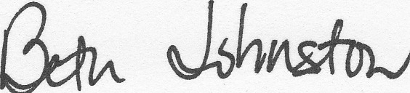

Beth Johnston
Chairperson, the Family Picnic for FSHD (Sept 2008)
Co-Chairperson, A Festive Evening of Music & Song 2010

Auction Timetable

This timetable assumes the date, venue and Committee for an overall Fundraiser Event have already been determined. If an auction is to be held as part of the overall event, ensure the venue is conducive to an auction.

6 months (or more) prior to the event

- Organize Auction committee
A successful auction requires a lot of work. No one should do it by himself or herself. Everyone on the Auction Committee should be responsible for procurement of auction items. A smaller group should focus on the actual arrangements and logistics of the auction.

- Determine size of auction
Determine in advance how many items you would like to have at the auction. The venue space may dictate this. Keep in mind items can be combined into like-item “packages” towards the end of the collection timetable.

- Send out letter appealing for contributions
Send a letter to local businesses, as well as the PR or “giving” departments of large companies.
  - Appendix A: Letter from the Director
  - Appendix B: Sample Procurement Letter
  - Appendix C: Donation Form

4 months (or more) prior to the event

- Begin Procuring items
Ensure all Committee Members are armed with Letters and blank donation forms. Don’t be afraid to ask EVERYONE you know for a donation – you’ll be pleasantly surprised how willing your friends, family and acquaintances are to donate something! Be sure to track all items that are procured.
  - Appendix D: Sample Auction tracking sheet

1 month prior to the event

- Begin auction item, certificate, and display preparations. Begin developing Auction Program
- Appendix E: Sample Display Sheet
- Appendix F: Sample Certificate (for intangible donations)
- Appendix G: Sample “chit” sheet (bidding sheet)
- Appendix H: Sample Auction Program

1-2 weeks prior to the event

- Close Auction procurement. Finalize Item categorization and grouping.
Now is the time to determine what items should be combined to make more appealing items, and what items should be included as part of a “live” auction, if there is to be one.
- Appendix E: Sample Display Sheet – to be displayed in inexpensive 8x10 frames next to each item.
- Appendix F: Sample Certificate (for intangible donations) – to be given to winning bidders of non-tangible items.
- Appendix G: Sample “chit” sheet (bidding sheet)

- Finalize & Print Auction Program (see Appendix H)

Day of the event

- Set up auction

- Track winning bids/bidders

- Conduct Live Auction (if necessary)

- Collect payments
  - Distribute items and/or certificates

Within 2 weeks following the auction

- Send letter thanking donors and Bidders
- Appendix I: Thank You Letter to Donor
- Appendix J: Thank You Letter to Bidder

Putting together an auction committee

Auction chair
This person is the leader of your committee. The primary qualifications for the Auction Chair are a willingness to serve and the ability to lead. The first order of business for the Auction Chair is to assemble the committee and lead that committee to set an ambitious yet realistic goal for the auction.

Procurement Team
The procurement team is a group of individuals who will be tasked with soliciting contributions to the auction. The ideal person for procuring is someone who has both the time and willingness to contact members by phone for donations.

Set up
This group is responsible for coordinating with the facility to arrange the event and make sure that tables are set up for the auction. They will also determine which items are placed where. Likely, this is the Auction Chair along with the Procurement Team.

Bid Tally/Check-out/Cashier
These individuals are responsible for documenting the winning bidders, totaling up each purchaser’s bill, collecting money and ensuring each winner receives their item(s).
Ideally, you will have several volunteers collecting the bid sheets at the end of the bidding period (quickly) and giving them someone to enter into a winning bidders board (either a poster, electronic spreadsheet or both).
Then, come checkout time, you will need several folks processing payments and “runners” to pickup and deliver the items to the purchaser.

Procuring items for your auction

The best ways to procure items is for Committee Members to contact people in their sphere of influence. Ask EVERYONE you know, and those places of business you frequent. Also approach area businesses and PR/giving departments in large companies.

- Send out a letter (Appendix B) to these businesses and/or large companies.
- Solicit friends, family, acquaintances and frequented businesses. Suggest items that they can contribute. Some items that tend to sell well include:
- Gift baskets
- Gift Certificates
- Anything for kids (parents and grandparents go crazy for these items!)
- Wine/food baskets
- Books/book baskets
- Sports memorabilia
- Golf Outings (friends with country club memberships)
- Jewelry and fashion items
- Artwork
- Show tickets / Entertainment
- Cash contributions can also be made.
- 2-4 weeks after sending the letter follow up with anyone who has not responded by calling asking for a donation, reference the letter they should have received.
- Have anyone contributing an item complete a donation form (Appendix C). Suggest they keep a copy for their tax purposes. Make sure the form is filled out completely. The address is important so a thank you letter can be sent following the auction. The item value is necessary for establishing the bid amounts.
- Arrange to pick up the item prior to the auction. Ensure them they will receive an acknowledgement letter after the Event for their records.

Setting up for the auction

One to two weeks prior to the auction:
- Make sure you’ve collected all items for the auction
- Confirm details with the facility where you will be holding the event
- Create bid sheets (Appendix G), display sheets (Appendix E), and winner’s certificates (Appendix F). The Bid Sheets are designed in Excel so that 2 items can be printed on one 8 ½ x 11 piece of paper, cut in ½, and attached to a sturdier sheet of card stock or construction paper for display.
- Finalize and print the Auction Program (Appendix H)
- Pick up any items you will need to decorate for the event or enhance item package presentation

The day of the auction:
- Arrange auction tables with items. I suggest organizing the tables/items by category. For example, have all entertainment items at one table or in one area, have all food/wine items at another, etc.
- Set bid sheets out with the items. Make sure you have a pen for each bid sheet. Nothing slows bidding down faster than having nothing with which to write your bid down!

How do you set bid prices?

The general rule of thumb is to start the bidding at 50% of the stated value of the item. The bidding increases from there in increments equal to 10% of the value (for convenience sake you can round). You can offer a “guaranteed bid” price, which means when someone bids the “guaranteed bid” price, the bidding stops and that bidder automatically wins the bid. The guaranteed bid price is typically equal to 150% of the stated value of the item.

For example:

Stated retail value = $50
Bidding starts at $25 and increases in increments of $5
Guaranteed bid price = $75

Collecting money

Before the auction:
- Determine which methods of payment you will accept. The more methods of payment you accept, the easier you make it for people to buy.
- Arrange for a credit card processing machine if you will be accepting credit cards.
- Arrange to have cash on hand to make change.
- Coordinate volunteers to help tally-winning bids at the auction.

During the auction:
- It is recommend that you have some form of entertainment or a speaker after the auction tables close to allow time to calculate purchases.

When the auction closes:
- After the auction tables close, QUICKLY gather up all bid sheets and begin tallying results. There are many different ways of doing this. Beforehand establish a method for doing this so it is quick and efficient. Bidders can be aggressive, especially when it comes to an item they really want to win. It is important all bid sheets are picked up at the same time.

Post-Auction follow up

Whew!! The auction is finished and hopefully you have met or exceeded your fundraising goals. Here are a couple loose ends to tie up:

- Send thank you letters to everyone who contributed an item to the auction (Appendix I).
- Send thank you letters to everyone who purchased something at the auction (Appendix J).
- Hold a wrap-up meeting with the Event/Auction Committee to discuss what worked well and what could be changed for your next auction.
- Keep a record of donors for your next event.
- Submit the information on your event to Nancy Van Zant at the FSH Society.

Appendix A — Letter from the Director
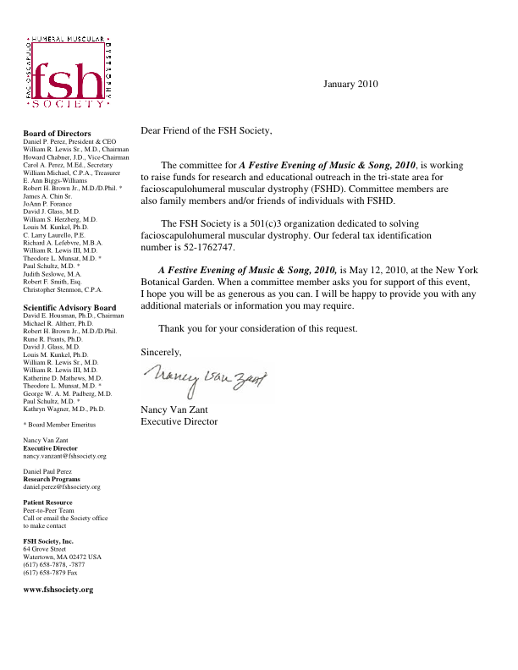

Appendix B — Sample Procurement Letter
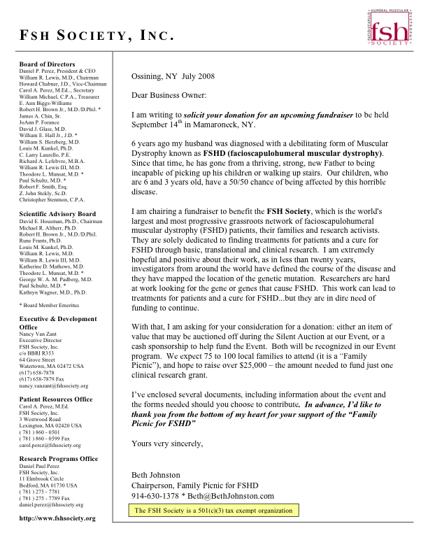

Appendix B — Sample Procurement Letter (2)
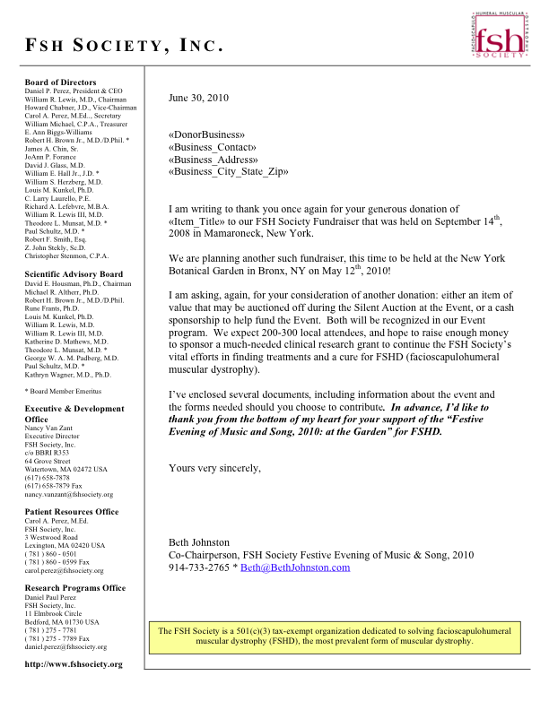

Appendix C — Sample Donation Form
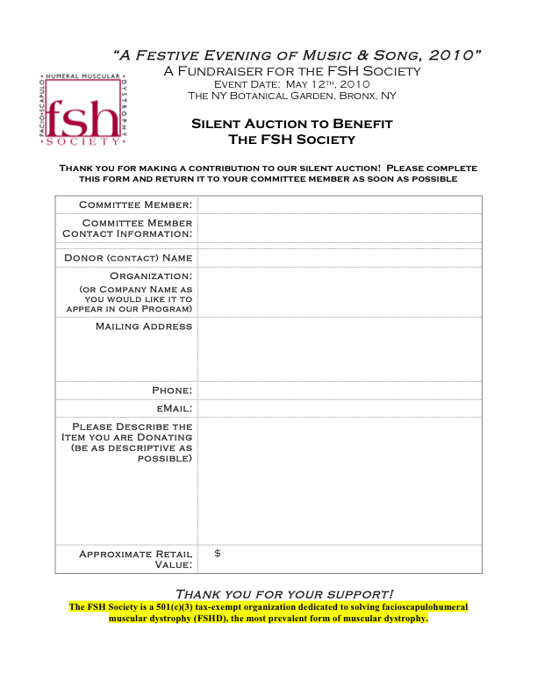

Appendix D — Sample Auction Tracking Sheet

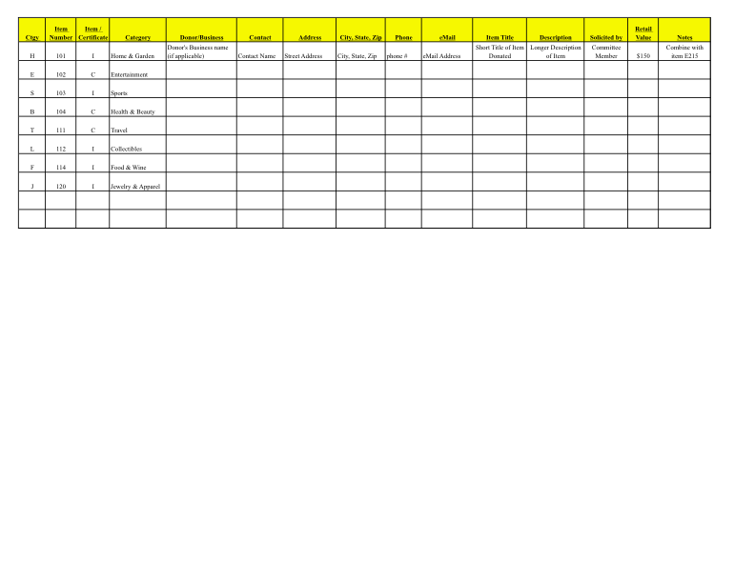

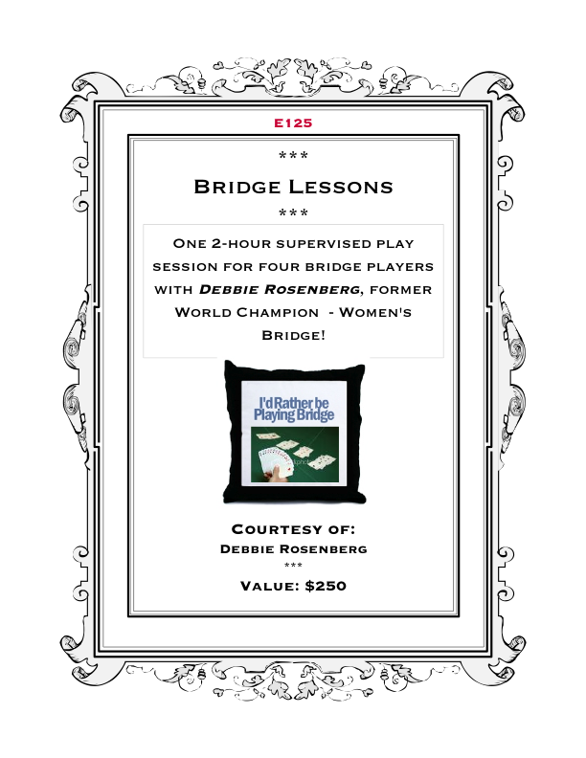
Appendix E — Sample Display Sheet

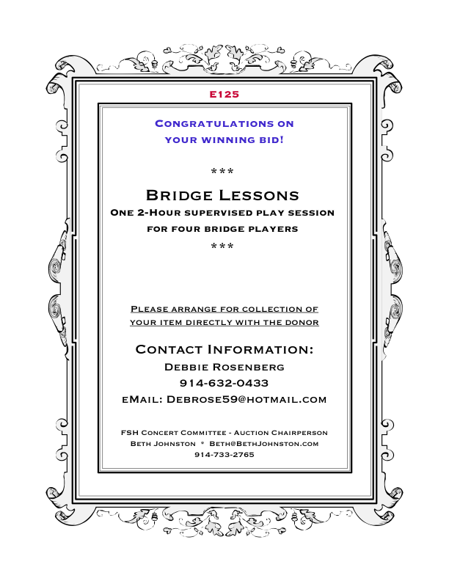
Appendix F — Sample Certificate

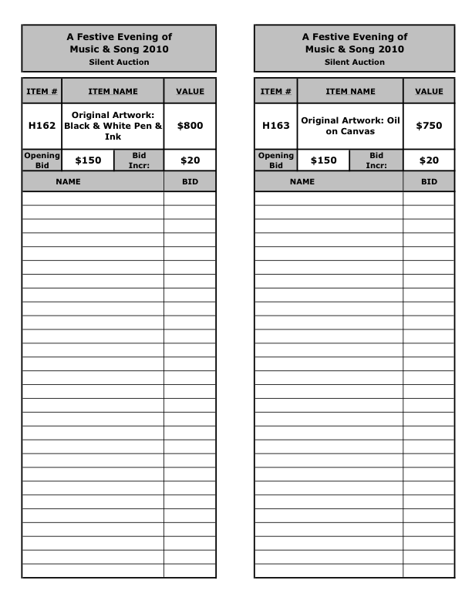
Appendix G — Sample Bidding Sheet

Appendix H — Sample Auction Program

(Hard copies distributed)

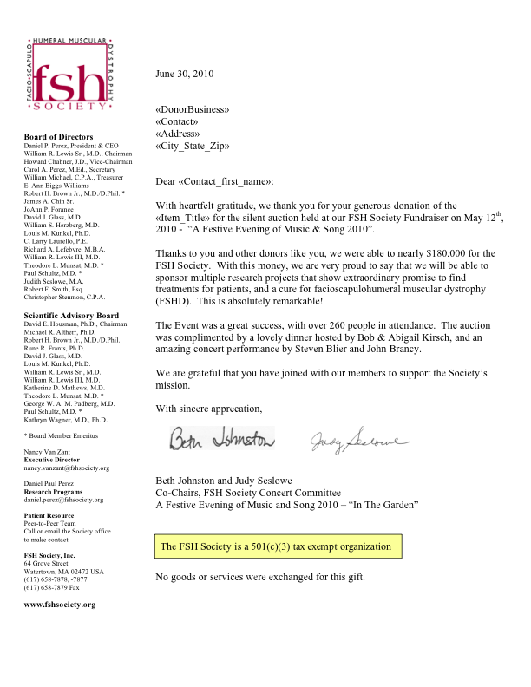
Appendix I — Thank You Letter to Donor

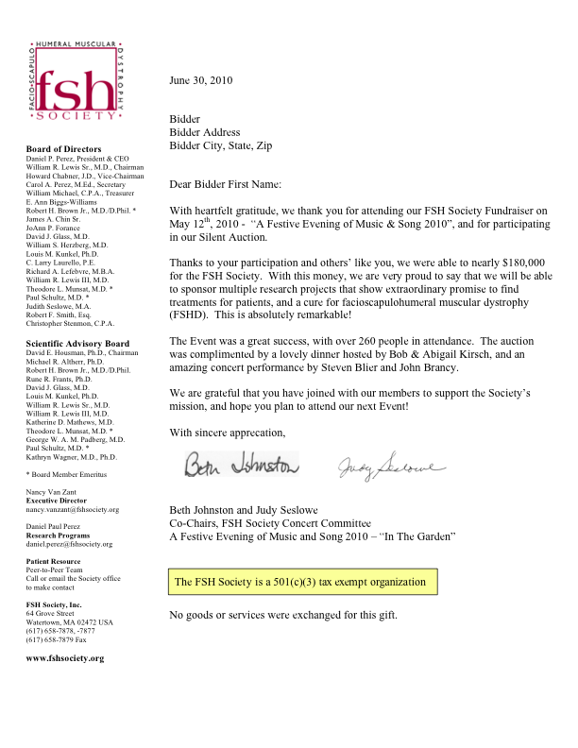
Appendix J — Thank you Letter to Bidder

